**Problem Statement :** Traverse an Graph Using BFS Algorithm in Python Programming Language.

**Objective :** Implement BFS Algorithm and Traverse a Graph Using Python Programming Language

**Source Code & Output :**

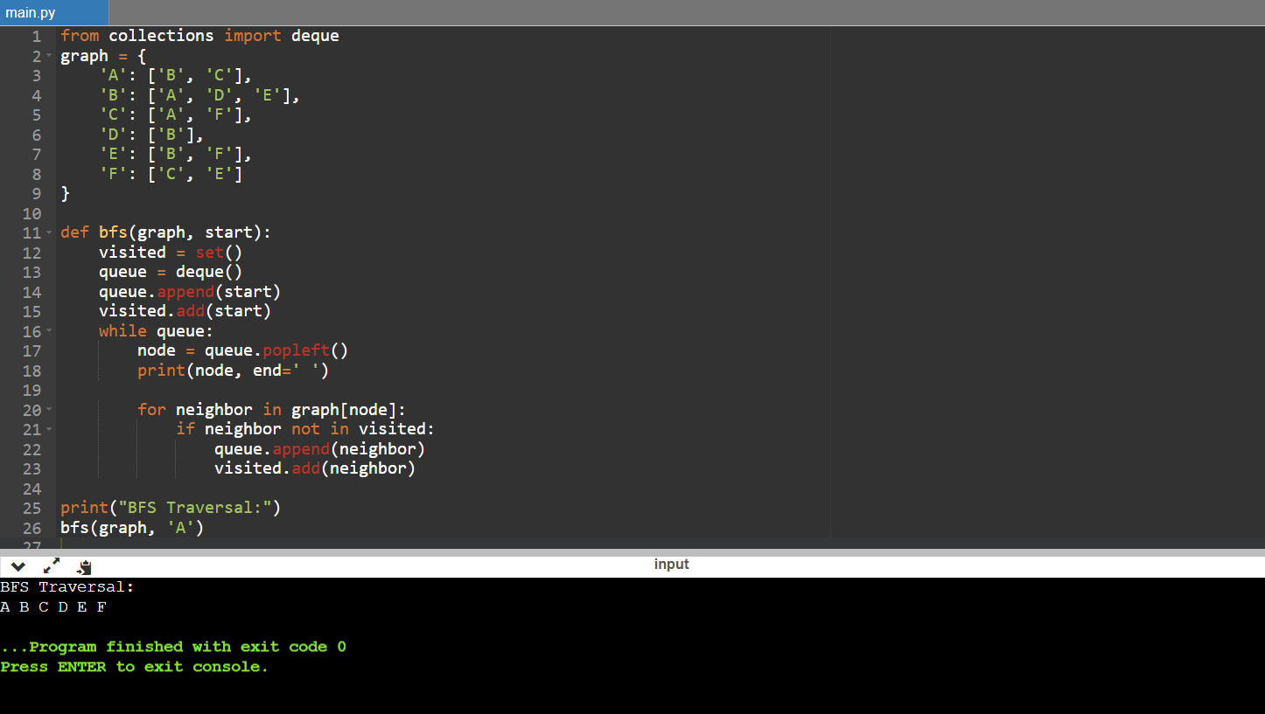

**Problem Statement :** Traverse an Graph Using DFS Algorithm in Python Programming Language.

**Objective :** Implement DFS Algorithm and Traverse a Graph Using Python Programming Language

**Source Code & Output :**

